***Al-Balqa Applied University***

Prince Abdullah Bin Ghazi Faculty of ICT

Visual programming

First Semester 2023-2024

**Homework #5**

## 2D-Graphics

## Exercise 1:

## Write an app whose main activity displays a custom view that draws the following figure.

## 

## – The outer red circle fills 100% of the main view's width and height.

## – There are 5 total circles, all centered; 3 red, 2 white.

## – Each circle is 20% smaller than the last:

## the first (red) is 100% of the window size,

## the second (white) is 80% of the window size,

## the third (red) is 60% of the window size,

## the fourth (white) is 40% of the window size,

## the fifth (red) is 20% of the window size.

## Exercise 2:

## Create a virtual fish that swims in a tank.

## C:\Users\Home\Documents\Android\lab web\Android Lab 6_files\lab6d.png

## Fish tank components:

## C:\Users\Home\Documents\Android\lab web\Android Lab 6_files\fish.png C:\Users\Home\Documents\Android\lab web\Android Lab 6_files\foliage.png C:\Users\Home\Documents\Android\lab web\Android Lab 6_files\tankbackground.png

## 

## Exercise 3:

## Create the following mobile App which will rotate the "arrow" shape by 90 degrees every time you click on "Rotate" button.

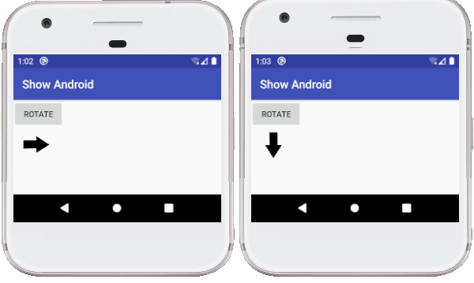

Use the following coordinates for path object:

Path path=**new** Path();  
path.moveTo(54,66);  
path.lineTo(121,66);  
path.lineTo(121,43);  
path.lineTo(190,88);  
path.lineTo(121,131);  
path.lineTo(121,107);  
path.lineTo(54,109);

Use pivot (center for rotate)

PivotX(118);  
PivotY(87);

**Exercise 4:** Complete the following onDraw method to display the following car:

## 

@Override      
protected void onDraw(Canvas canvas) {  
        super.onDraw(canvas);  
        .................  
}